React Web App – Decisioning Dashboard

Benjamin Roberts

Level 4 Software Development

Contents

Table of Figures 3

Glossary of Acronyms 4

Acronyms 4

Terminology 4

Introduction & Requirements 5

Project Description 5

Acceptance Criteria 5

Summary of Stakeholders Involved 6

Design 7

Initial Draft for page template 7

Wireframe 8

Implementation / Development 9

Initial setup of the React application 9

Setting up Dependencies 9

NPM Audit – Addressing Dependency vulnerabilities 10

Setup a Node.JS backend for SQL Access 12

Debugging Compile Errors (MSSQL) 12

Backend Set up in Node.js 13

Personal Data (PII) Protection 14

Deployment 15

Hosting in Azure Static Web App 15

Confirming access 18

Testing 19

UAT – Gathering user feedback 19

Review with Employer 20

Conclusions 21

Project Outcome 21

Future Additions 21

References 22

Appendix 23

Initial Backend attempt, with React & Node.JS using concurrently 23

# Table of Figures

Figure 1- Initial draft Wireframe drawn on Whiteboard 7

Figure 2 - Figma Wireframe of a Home Page for the React app 8

Figure 3- Output of npm audit command, showing a list of known vulnerabilities which could compromise the application 10

Figure 4 - Output of npm audit fix command, showing that breaking changes would be needed to fix the identified vulnerabilities 11

Figure 5- Importing "mssql" into a React Component called "Home.jsx" 12

Figure 6- Compile error from importing the "mssql" library 12

Figure 7 - Initialising an Express app based on a templete 13

Figure 8 - Install http-errors dependency 13

Figure 9-Top Bar Navigation for all pages on the application 17

Figure 10 - CSS code used to make the Top Navigation bar scroll with the user 17

Figure 11- Applying CSS for the Navigation Bar 18

Figure 12 - Top Bar Navigation scrolls with user 18

Figure 13 - Hardcoded URL within the React Application 21

Figure 14 - .env file added to allow dynamic configurations without altering the raw code 21

Figure 15 - Altered code to use the newly created .env file 22

Figure 16 - Setting up an Azure Static Web App to host the React application 25

Figure 17 - The React App home page as deployed to the Azure Static Web App 27

Figure 18 - Confirmation a user can access the deployed React App 28

# Glossary of Acronyms

Below is a series of Acronyms and terminology definitions that will be useful for understanding concepts throughout the project

## Acronyms

|  |  |  |
| --- | --- | --- |
| **Acronym** | **Name** | **Meaning** |
| MI | Management Information |  |
| UAT | User Acceptance Testing |  |
| CSV | Comma Separated File | A type of Raw data file with values separated by comma characters. Useful for transferring simple datasets between systems due to its simple design allowing the file to be read easily. |
|  |  |  |
|  |  |  |
|  |  |  |
|  |  |  |

## Terminology

|  |  |
| --- | --- |
| **Term** | **Description** |
| Raw Data |  |
| Scorecard |  |
| Summary Data |  |
| CAIS | Acronym for Credit Account Information Sharing – Financial Service providers share account information with credit bureaus as a trade off for being able to access this data as part of their “Know your Customer” checks and for assessing credit worthiness.  CAIS is an acronym for this process used by Experian, 1 of the 3 Credit Bureaus operating in the United Kingdom. |
|  |  |
|  |  |

# Introduction & Requirements

With my team being responsible for developing and maintaining our Credit Decisioning system, we require various kinds of Management Information (MI) and views of the data used by the platform (both in the aggregate and within individual applications). This is also important for monitoring the performance of the platform.

Today, we use various tools to monitor and report on the performance of the system e.g.:

* Ad-Hoc analysis done via querying a SQL Database
* Summarised Microsoft Excel Reports
* Microsoft Power BI reports
* Manually extracting and reviewing raw data (typically via SQL)

All these tools are useful for their specific purposes but what they don’t do is give us a presentable view of the low-level data used in making a decision on an application. We could license other software for this purpose e.g. the Credit Bureau providers Experian, TransUnion and Equifax all provide software to present the data they hold on an applicant. These however require software licenses to be purchased. I believe we could use the React Framework to build a similar tool that would be more bespoke to our business needs.

## Project Description

Using the React Javascript Framework, design and develop a simple Web Application to:

1. Leverage the Java Decisioning Application I developed in a previous project & it’s logged output (Link: [GitHub - Java Credit Decisioning Program](https://github.com/btr6566/qam1_java_decisioning_app))
2. Display a list of recent applications made to the Credit Decisioning system
3. Allow a user to click on a specific application to view the data used for it in more detail
4. Provide reference material for the data definitions of the data used (i.e. a Data Dictionary function)

## Acceptance Criteria

1. Wireframe of the design of the website is provided
2. Final product aligns to the wireframe
3. Intuitive user interface created & evidenced via feedback from technical & non-technical stakeholders
4. The web app is able to query a database where logs from the Decisioning program/software are retained
5. Low level detail of the data used in the application, including:
   1. Data used for running Scorecards + their values
   2. Summary data on an applicants Credit file
   3. Raw data used to create the above summary data

# Design

To give myself a starting point, I referred to the Software Development Life Cycle, which as “design” as a key starting point for build a piece of software (Amazon AWS, 2024). With the requirements already defined, I needed a design to work towards.

## Existing product for inspiration

From my time in the workplace, I was aware of a similar product that provided similar functionality to what I was aiming to achieve in this project. I believed it would be worthwhile to examine this product as a source of inspiration for how to approach my project.

I did not have access to this product myself, but I knew a colleague who did. I sent them a message over the Microsoft Teams application asking if they could share some screenshots of what they see within this product. They provided me with 5 screenshots.

Figure 1- Requesting screenshots of a similar existing product from a colleague

I’ve not included the provided screenshots in this report & have removed the majority of the previews from the figure above. This information can be considered trade secrets, so this was done to protect the privacy of the stakeholders involved.

## Wireframes

With some inspiration from an existing system Vanquis Banking Group already use, I started with a draft wireframe and then expanded upon it with a 2nd iteration.

### Initial Draft for page template

To keep a simple process to start, I drew a basic template on a white board for that I had in mind for a “home” page:

Figure 2- Initial draft Wireframe drawn on Whiteboard

Doing this simple approach gave me a way to get a starting point for what I wanted the layout of my application to look like, without having to decide on specific details (like styling).

### Figma Wireframe

The whiteboard draft was useful to get a foundation, but I wanted to go into a little more detail before I started creating the React Application. This meant I needed a more detailed wireframe.

Figma is a solution I was familiar with, as our internal Marketing team have shared wireframes they’ve created for internal projects with me previously in the past. I believed this made it a good tool to look at for developing my wireframe into something ready for development.

Below is what I created for the Home page. The idea was to use this as a template for the design of the remaining pages.

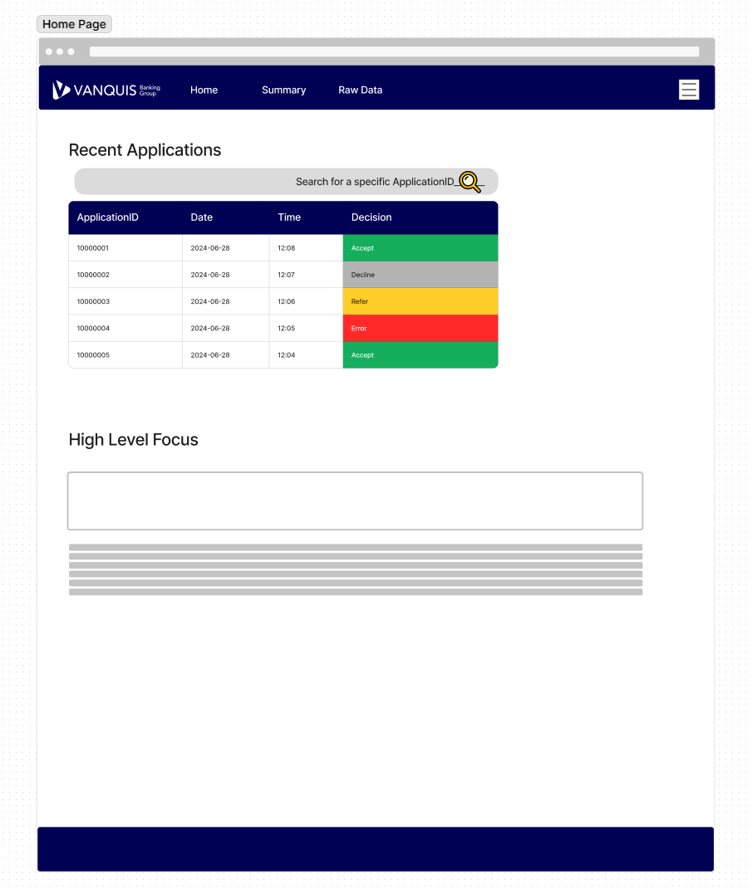

Figure 3 - Figma Wireframe of a Home Page for the React app

One key change I made from my initial draft wireframe was to use a header Navigation Bar instead of a left-hand side bar. This simplified the layout of the website and meant the functionality presented to the end user could be focused here, allowing them to navigate the core of the application more easily.

For styling, I consulted our Vanquis Banking Group branding guidelines. I wanted something that looked like it could really be in use in the organisation & to do this effectively, it was critical to follow the branding guidelines to provide a professional appearance to corporate material (Iconic Digital Marketing Agency, 2024).

# Development

## Backend Setup – for supporting functionality

Some of the requirements I set required a full Backend to be created to implement the functionality required. This included:

* Ability to connect to a database to retrieve application data (an Azure SQL Server Database specifically was used in the project)
* Searching an External file for definitions of data variables

### Why one was required

Initially I tried importing the “**mssql**” package directly into the React component to meet the 1st use case of connecting to a database to retrieve application data. When doing that however, I faced 26 compiler errors in React. These came about purely from importing the library for use:

Figure 4- Importing "mssql" into a React Component called "Home.jsx"

Figure 5- Compile error from importing the "mssql" library

One thing I didn’t understand was what this “**Polyfill**” concept the error messages referred to. That felt like the 1st step to resolving the error, so I did some quick research. I found that **Polyfills** are pieces of code to provide modern functionality to older browsers, at the expense of functionality and performance (Mozilla, 2024). From the context of the error message, I can see that this means that the “crypto” module mentioned in the error message is no longer automatically included, so creating a **polyfill** is necessary to resolve.

Attempting to create one of these polyfills did not resolve my issue. From further research I concluded that it would be significantly easier to set up a back-end application that the main React application could call over HTTP e.g. via the fetch method. This allows offloading complex logic into a separate app and avoids the need for complicated polyfill logic.

### Initialising Node.js Express

After some trial and error, I came to think that it would be easiest (to develop and maintain) a separate Node.js Backend and use HTTP calls within the main React application to get the necessary data. That creates a clear distinction between front-end and back-end, plus means they can be maintained separately. I found the Express framework from some research, which provided the framework I needed and could be generated with a command line function, shown in the figure below (Express, (n.d.).



Figure 6 - Initialising an Express app based on a templete

This did require an additional dependency via a library called “http-errors”, as shown in the figure below. To resolve this, I ran another npm install command to add this into my repository.

Figure 7 - Install http-errors dependency

## Front End – React

Details of specific functionality developed for the Front End are given below:

### Top Navigation Bar

Critical to the application was a user navigation interface. I wanted something simple that was always accessible by the user no matter where they were on the page, hence a navigation bar at the top of the screen. Using my wireframe as a reference, I created the below:

Figure 8-Top Bar Navigation for all pages on the application

The below figure shows the HTML and React code that creates this navigation bar, called “NavBar.jsx” within the files. This is designed to return a simple <nav> html object to the page where this component is rendered, allowing it to be reused across the application. Link objects from the “react-router-dom” library are used to link to the different pages of the application, which allows the user to switch pages without triggering a refresh of the web browser used (React Router, n.d).

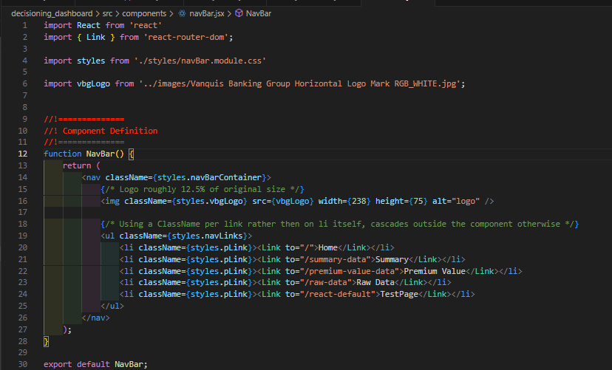

Figure 9- HTML and React Code for the Navigation Bar

This “NavBar.jsx” component is then placed within the root “App.jsx” component of the React Front End application, allowing it to be displayed across all pages. It is placed within the parent <BrowerRouter> component provided by “react-router-dom” library to provide seamless navigation between pages.

Figure 10 - NavBar Component placed into the main App.JSX Component

To meet the desire to have this navigation bar visible to the user no matter how far they scroll on the page, I added CSS logic. The <nav> html tags that contain the Navigation bar has the “sticky” position property applied to it, which enables this feature (W3Schools – CSS Position, 2024).

Figure 11 - CSS code used to make the Top Navigation bar scroll with the user

Below is an example of this feature working as expected. In this example, a user has scrolled down one of the pages while viewing a table component. Despite this however, we can see the top navigation bar has stayed at the top of the users window, allowing them to access it immediately.

Figure 12 - Top Bar Navigation scrolls with user

### Side Bar Navigation for longer pages

One issue I felt while developing the pages that displayed the detailed application data to the end user was that displaying all this data resulted in very long web paged e.g. shown below is a page called “Premium Value Data”, which displays various data points provided by Experian (2024). This section of the data has multiple sections, each with many variables. The React application renders these as HTML tables, but the number of variables in each section results in a long web page, making it difficult to navigate.

Figure 13 – Webpage with enough content to require the user to scroll down to view different sections

To address this, I went back to the side bar navigation idea I had on my original wireframe. This provided a way to provide section links on the page, allowing the user to navigate quickly to various sections. Applied to the Premium Value Data page, this appears as below:

Figure 14 - Side Bar for the PremiumValueData page, with links to each section and sub-section

Figure 15- Original CSS, with an issue on the "top" property not working as expected

Figure 16- Altered CSS, with unnecessary properties removed & issue with "top" property fixed

### Environments configuration

One stretch goal I wanted to achieve with this project was to have the final application in a state where it would be ready to be deployed to an actual environment aside from the localhost I developed on. The aspiration was to have a UAT version of the application I could share with colleagues and gather feedback on the usefulness of the app & how easy it was to navigate.

To do this though, I had to deal with a logical flaw in my code. For example, to meet the requirement of displaying a list of recent applications, the front end React app makes a HTTP call to the Backend via the “fetch” method, which enables HTTP calls to be made in base JavaScript (W3Schools, 2024, Fetch API). In my first version of this however, I hardcoded the URL the fetch method would call, as seen below:

Figure 17 - Hardcoded URL within the React Application

This logically would not work anywhere but my local machine, so this was a barrier to meeting this deployment aspiration. To address this, I created a “.env” file that my React App could read from when it is started to get the appropriate variables for a given environment:

Figure 18 - .env file added to allow dynamic configurations without altering the raw code

I then altered my code to use this environment instead of the hard-coded value it previously had:

Figure 19 - Altered code to use the newly created .env file

For localhost development, I used the same localhost:port URL I had before, allowing the app to still work on my development machine. When it comes to a deployment however, I can now swap this .env file for a configuration appropriate to the environment e.g. a ”.env.uat” file with the URL for a UAT version of the back end.

The naming of the variable is due to React requiring the “REACT_APP_” prefix on all variables, which allows React to find the variables when using the default “npm start” command to start the server (Facebook, 2024).

### SQL - Search for Recent Applications

### SQL - Search for external Credit File data

### Data – Decoding for Business Users

One issue I had to solve was to consider how end users would understand the data presented to them by the application. There was however a complication caused here by the data sources used for this application, as a key part of the data used comes from data provided by Experian’s API for accessing data they hold on a person (Experian**,** 2024). This challenge manifests itself in 2 ways:

**Scenario 1**: Names of variables are highly codified to make their meaning unclear at 1st view e.g. E1B08 is a variable returned by the Experian API. Without it’s documentation as shown below however, this gives no indication as to what the variable means in business terms.

Figure 20- Definition of E1B08 from Experian (2024) documentation

**Scenario 2:** Some variables may have clear business names but the values used are codified and would not make sense without documentation to explain the values e.g. the AccountStatus variable shown below has 4 values but only shows 1 character. Some of these are intuitive but others can be confusing e.g. F standing for default.

Figure 21 - Definition of AccountStatus from Experian (2024) documentation

These cases were going to be a key blocker to having an application that could effectively communicate its content to the end user if left unresolved. Functionaliy to provide easy to access definitions to the end user was required to avoid this issue. The nature of both issues meant that I could approach each separately.

#### Scenario 1 resolution

This was the more complicated scenario to solve, as the Experian API used as the data source contains 1000’s of variables per its documentation (Experian, 2024). Rendering a description for each of these did not seem practical or efficient.

After discussing the issue with my colleagues in the Credit Systems team, The solution I arrived at to handle this was to instead provide the functionality for a user to automatically get the definition of a variable as needed. This presented an acceptable compromise between being able to communicate data to end users and keeping the application code simple.

To make this work, I needed a dictionary source that the application could use to look up variable descriptions. To keep this simple I decided to use a CSV file to store both the variable names and a description, the variable name being used to match to. Using this kind of lookup also allows the program to store it’s own definitions of variables if the documentation provided is lacking. For reading CSV files, I required a node.js library called csv-parser, so I installed this:

Figure 22- Installing csv-parser

Using this library, I created a function within my Backend Node.JS express application. I did this in the Backend as trying to import one of the dependent node modules resulted in an error:

Figure 23- Error attempting to load a dependency directly into React for my lookup function

As I found out when trying to establish a connection to a SQL database, it’s easier to offload this logic to a dedicated Backend application rather than handle polyfills to get the logic working directly within the front-end application.

##### Backend Logic for lookup function

To provide a point of interaction, I needed to expose an Endpoint that the FrontEnd could send a HTTP call to. An Endpoint represents a point where 2 applications can talk to each other (Yasar, K, 2024), so creating one in my backend is required for it to be able to communicate with the front end.

To do this, I created a new router object within the Node.js Express application, using one of the default ones provided by the officially provided generator (Express, n.d.) as a starting point. I added in a URL Parameter which will allow a variable name to be passed in to carry out a search for it’s definition. This is done via the “:searchKey” parameter seen in the router.get() method:

Figure 24- Router.Get method for the backend to accept a search parameter

Once that endpoint is in place, the parameter is be passed into a dedicated asynchronous function that performs the lookup on the CSV file (the function is asynchronous as a regular function generated errors within the code editor). The function is then wrapped in a Try-Catch to account for the possibility of an error e.g. the input file not being available. The result is then loaded into a JSON payload and sent back the calling application (i.e. the FrontEnd) via the res.send() method.A screen shot of a computer program

Figure 25 - Endpoint logic showing the lookup function being used & sending this back to the calling application

##### Front End Logic for lookup function

For the front-end, I coded the function as below:

Figure 26 - Code for Lookup functionality

This code will:

1. Accept an input parameter called “key”, which will hold the variable name we want a definition for
2. Attempt to retrieve the definition by using the “fetch” function to make a HTTP call to the Backend, using a host name stored within the process environment and passing in the “key” as part of the URL
3. Fetch will return 1 of 2 outcomes:
   1. An error is thrown if there is a network error
   2. Parse a successful response for a variable called “description”
4. Assuming a successful response, the description returned by the Backend is provided to the user via Javascript’s inbuilt “alert” method

Each variable that contains data the end user can review is rendered in the application by a React component called “KeyValueRow”. Within this component, this lookup function is then called via the “onClick” property of the table row that displays the data to the user:A screen shot of a computer program

Figure 27- OnClick property using the lookup function

When the function is successful, a definition will pop up on the end users screen e.g. for the E1B08 variable, the below prompt is currently presented to the user:

Figure 28 - Lookup prompt presented to the user for E1B08

The row within the table will also highlight, to give the user an indication that the row can be clicked on to bring this definition up. An instruction is also given at the top of the table.

Using an alert textbox for this allows the description to be communicated to the end user easily without the need for more complex HTML & CSS components to render the description on page.

#### Scenario 2 resolution

Translating the values of a given variable into business friendly language could be done in a more simple approach then the 1st scenario. So long as the documentation provided a dictionary of values, it was possible to code a switch statement to return a detailed value that communicated more clearly with business users. Taking the “AccountStatus” variable as an example, I added this switch case into the code:

Figure 29- Switch case to translate AccountStatus into a business friendly value

This is written directly into a React component called “CaisRow”, which receives the coded value for AccountStatus as part of a prop called “CAISDetails”. This is then parsed to get the raw value. A business friendly value can then be returned by simply passing this value into the switch case:

Figure 30 - CaisRow component return statement, showing the translated value in use

This “CaisRow” component gets rendered multiple times based on the data received by the program:

Figure 31- React JSX code showing the rendering of the CaisRow components via the .map() method

When the React application renders these CaisRow components, we can see a clear test value has been rendered for the user, instead of the shortened value that could be mis-interpreted.

Figure 32 - Rendered React application showing the business friendly language used instead of the original values

This same technique was then applied to any similar variables, allowing clear values to be shown instead of original values requiring documentation to interpret.

## Personal Data (PII) Protection

~~This access management configuration can also be used for another purpose: protecting Personal Data (PII). Credit Decisioning Systems like this must collect personal data to be able to conduct a credit search on a person e.g. Experian’s DelphiSelect API requires at least:~~

* ~~Full name of the person in question~~
* ~~Date of Birth~~
* ~~At least the current address of the person in question~~
* ~~Previous addresses are also often needed if the person in question has resided at their current address for less than 3 years~~

~~(Experian, 2024)~~

~~Each of these Data Points are protected under the UK's Data Protection Act 2018, which also codifies the GDPR into UK Law (Data Protection Act, 2018). The program is currently collecting the Full Name of the user as a starting point to allow a full API integration in future. This means the program must be mindful of Data Protection/GDPR requirements.~~

~~Using a SQL databases within the program creates the risk of SQL Injection, where malicious input into the program can lead to arbitrary execution e.g. a user passes in a SQL command instead of a name (W3Schools, 2024). This is where the SELECT and INSERT permissions assigned above come into effect. The Full Name collected in the application is only saved to the “dbo.JavaDecisioningHistory” , which the integration user only has INSERT permissions on. This prevents a malicious user from entering a query to retrieve data from this table, as the database permissions will result in the query being rejected.~~

~~The only other permission the Integration User has been granted is the SELECT permission on the “Delphi.VW_DelphiPremiumValueData” and the “Delphi.VW_DelphiSummaryData” views. These are the only other views required by the program, so by limiting the access like this the possibility of risk incurred by SQL Injection is minimised and therefore acts as a control to protect Personal Data.~~

# Final Tech Stack

By the end of my project, the final Tech Stack looked like this:

Figure 33 - Diagram showing the Tech Stack of the full application

# Testing

## Review with Employer

### 1st Feedback

When I was ready to show the navigation, I made use of a regular 1 to 1 with my Line Manager to gather some feedback on the application.

Figure 34 - Teams Call arranged to discuss Apprenticeship progress

## UAT – Gathering user feedback

# Final Application

# Conclusions

Below are my thoughts from reflecting on the work completed for this project:

## Project Outcome

For the most part, the final application did achieve it’s aims and met its requirements, however I did run into many challenges being able to make this work.

Being unable to include the “mssql” Node.js package directly into my React application was a significant hurdle I had to overcome to complete this project, as making a database connection was a fundamental requirement set in the project acceptance criteria. Researching the errors I was getting led me to concepts I had not encountered before e.g. polyfills. I was able to eventually resolve the errors I faced by setting up a dedicated backend, but this had the impact of unexpected scope creep.

## Future Additions

If I were to take this project further, below are a few things I would like to add/do differently:

* Try using a different framework for the backend rather than the Node.js Express framework. I found this framework to be awkward to use for the functionality I needed, mainly due to the confusing syntax around how it defines it’s endpoints and how it makes the request and response available to the developer
* Explore using a dedicated CSS Framework to handle the formatting of the Front End application. CSS is something I have not been enjoying working with, so Frameworks to simplify its use would be preferable to use in future. Frameworks I could look at include: Bootstrap, Tailwind & Foundation (W3Techs, 2024 and WeAreDevelopers, 2023)
* Rethink how the lookup function in my code used to display the data definitions works. While the version I have works, it has a few flaws I’m not satisfied with:
  1. Using the native Javascript alert() function poses a breaking issue if the users machine blocks these e.g. Firefox provides this functionality (Mozilla Support, n.d.). It would be preferable to display a dedicated HTML element with the information that can be dismissed by the user.
  2. A CSV file I don’t feel is the most reliable way to store this information. One key issue I have is that the current solution only works reliably if there is a single record in the file to return, which I believe would break from a full UAT test of the application. From speaking to a peer privately (who does not work for Vanquis), an alternative we identified was a SQLite database, which is a lightweight public domain database what can be deployed directly with an application (SQLite, n.d.).
* Discover how to get a working deployed version of the full application (Front End and Back End) that are capable of communicating with each other. The furthest I got with this project was deploying a Front End only (see Appendix). This will be critical to making my developed applications available to end users.

# References

Amazon AWS. (2024). What is SDLC (Software Development Lifecycle)?. [Online]. AWS. Last Updated: 2024. Available at: <https://aws.amazon.com/what-is/sdlc/#:~:text=The%20software%20development%20lifecycle%20(SDLC,expectations%20during%20production%20and%20beyond>. [Accessed 28 June 2024].

Barger, R. (2021). How to Create a React App with a Node Backend: The Complete Guide. [Online]. FreeCodeCamp. Last Updated: 2021. Available at: https://www.freecodecamp.org/news/how-to-create-a-react-app-with-a-node-backend-the-complete-guide/ [Accessed 5 July 2024].

Experian. (2024). DelphiSelect API Documentation - for Credit Decisioning data. [Online]. DelphiSelect API Documentation. Last Updated: 2024. Available at: <https://developer.experian.com/products/uk/delphi-select/delphi-select-api-docs> [Accessed 17 May 2024].

Express. (n.d.). Express application generator. [Accessed July 6, 2024], from <https://expressjs.com/en/starter/generator.html>

Facebook. (2024). Adding custom environment variables. *Create React App Documentation*. Available at: <https://create-react-app.dev/docs/adding-custom-environment-variables/> (Accessed: 5 August 2024).

Iconic Digital Marketing Agency. (2024) The importance of brand guidelines. Available at: <https://iconicdigitalagency.com/blog/branding/the-importance-of-brand-guidelines/> (Accessed: 5 August 2024).

Mozilla. (2024). Polyfill. [Online]. developer.mozilla.org. Last Updated: 2024. Available at: <https://developer.mozilla.org/en-US/docs/Glossary/Polyfill> [Accessed 5 July 2024].

Mozilla Support. (n.d.). Pop-up blocker settings, exceptions and troubleshooting. [online] Available at: <https://support.mozilla.org/en-US/kb/pop-blocker-settings-exceptions-troubleshooting> [Accessed 6 Aug. 2024].

React Router. (n.d.). Link. [Online]. React Router - Link Object. Available at: <https://reactrouter.com/en/main/components/link> [Accessed 9 August 2024].

SQLite. (n.d.). SQLite Features. [online] Available at: <https://www.sqlite.org/features.html> [Accessed 6 Aug. 2024].

Stack Overflow. (2024). babel-preset-react-app, is importing the "@babel/plugin-proposal-private-property-in-object" package without declaring. [Online]. Stack Overflow. Last Updated: 2024. Available at: <https://stackoverflow.com/questions/76435306/babel-preset-react-app-is-importing-the-babel-plugin-proposal-private-propert> [Accessed 28 June 2024].

Yasar, K. (2024) 'What is an API endpoint?', *TechTarget*, July. Available at: <https://www.techtarget.com/searchapparchitecture/definition/API-endpoint> (Accessed: 5 August 2024).

WeAreDevelopers. (2023). Best CSS Frameworks. [online] Available at: <https://www.wearedevelopers.com/magazine/best-css-frameworks> [Accessed 6 Aug. 2024].

W3Schools. (2024). Fetch API. Available at: <https://www.w3schools.com/jsref/api_fetch.asp> (Accessed: 5 August 2024).

W3Schools – CSS Position. (2024). *CSS Layout - The position Property*. [Online]. W3Schools - position. Last Updated: 2024. Available at: <https://www.w3schools.com/css/css_positioning.asp> [Accessed 9 August 2024].

W3Techs. (2024). Usage statistics and market share of CSS frameworks for websites. [online] Available at: <https://w3techs.com/technologies/overview/css_framework> [Accessed 6 Aug. 2024].

# Appendix

Below is some additional work I did for this project, but have not included as part of the final project. Reasons for this include:

* Work was made redundant with later commits made to the repositories
* Work was incompatible with the end goal of the project or it’s asperations

## Initial Backend attempt, with React & Node.JS using concurrently

The “mssql” module I need to connect my React application to an Azure SQL Database is a Node.js module, so I needed to create a Node Backend to be able to make use of this. I follows I guide from (Barger, R, 2021) to do this.

This worked on my local machine. However it did not when I deployed to my Azure host. Rather then debug this, I thought it would be easier to implement a separate Node.js server as a backend and access as an HTTP call in the React Application. Therefore, this was scrapped.

## Setting up Dependencies

* React-Router-dom

* MSSQL

Missing:

Fixed via (Stack Overflow, 2024).

## NPM Audit – Addressing Dependency vulnerabilities

Figure 35- Output of npm audit command, showing a list of known vulnerabilities which could compromise the application

## Hosting in Azure Static Web App

One thing I wanted to do to allow testing of the application is to make it available to other users, which would enable UAT testing directly with multiple colleagues. To do this though, I needed a way to deploy the application.

I already had a Visual Studio Professional subscription (which has monthly Azure credits) from my employer, so this was my 1st idea for a hosting solution. I came across the Static Web App resources, which would allow me to link to the GitHub repository directly. Shown below is how I configured this:

Figure 36 - Setting up an Azure Static Web App to host the React application

After the deployment, I tried using the default URL Azure provided to see if I could access the application. This was successful:

Figure 37 - The React App home page as deployed to the Azure Static Web App

### Confirming access

I needed to know if this deployed application was accessible by other users. To confirm this I asked one of my colleagues (referred to as MO in the screenshot below) to try accessing the link and confirm what they see. This was successful:

Figure 38 - Confirmation a user can access the deployed React App

This gave me a proof of concept that this method of deploying a React Application to an Azure based host would work with the resources available to me. When the need for a full Backend became apparent however, I needed to consider how the deployed application would communicate with the Backend, which I did not consider with this Static Web App. I therefore scrapped this and investigated alternatives.

## Learning Criteria

S2 - Develop effective user interfaces

S8 - Create simple software designs to effectively communicate understanding of the program

B10 - Committed to continued professional development

B4 - Works collaboratively with a wide range of people in different roles, internally and externally, with a positive attitude to inclusion and diversity

B7 - Communicates effectively in a variety of situations to both a technical and non- technical audience

B5 - Acts with integrity with respect to ethical, legal and regulatory ensuring the protection of personal data, safety and security

B1 - Works independently and takes responsibility. For example, has a disciplined and responsible approach to risk, and stays motivated and commited when facing challenges

B6 - Shows initiative for solving problems within their own remit, being resourceful when faced with a problem to solve

B8 - Shows curiosity to the business context in which the solution will be used, displaying an inquisitive approach to solving the problem. This includes the curiosity to explore new opportunities, and techniques; the tenacity to improve methods and maximise performance of the solution; and creativity in their approach to solutions

B9 - Demonstrates creativity and tenacity in their approach to solutions and the methods used to come to a solution, for example sees the task through to the end by devising new solutions and despite obstacles and problems along the way